# Image result for south metropolitan tafe logo

REPORT ON SENSORS

USED IN CNC LATHE

BY-SANDEEP SINGH

STUDENT ID – M228854

# SLIDING DOOR SENSOR

Motion detectors, or optical sensors, are the most common types of sensors used on automatic doors. These sensors detect movement and are installed on the sides of the doors. Once movement is detected, the doors open. Another common type of sensors used for automatic doors are pressure sensors. These sensors are placed in a large area in front of the door and they sense pressure, which causes the doors to open. Door sensors work because they use a sensor and a magnet. The sensor is placed on the door frame and the magnet on the door itself. A circuit attached to the magnet sends a message to the alarm when the current is disturbed when the door is opened.

Reference <http://www.autonics.com/products/products_detail.php?catecode=01/04/01&db_uid=64>

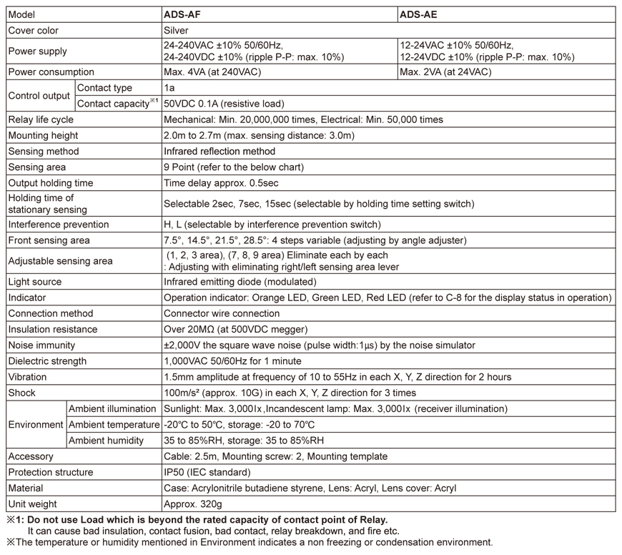

We need the ADS-AE type for sliding door sensor.

NUMBER NEEDED- 1

TOTALPRICE - $278.76

# LIMIT SWITCHES

In [electrical engineering](https://en.wikipedia.org/wiki/Electrical_engineering) a limit switch is a [switch](https://en.wikipedia.org/wiki/Switch) operated by the motion of a machine part or presence of an object.

They are used for controlling machinery as part of a [control system](https://en.wikipedia.org/wiki/Control_system), as a safety interlocks, or to count objects passing a point. Limit switch is an electromechanical device that consists of an actuator mechanically linked to a set of contacts. When an object comes into contact with the actuator, the device operates the contacts to make or break an electrical connection.

Visible operation  
Able to switch strong currents – 10 A conventional thermal current  
Electrically separated contacts  
Precise operating points – consistency  
Variety of operating heads, plain plunger, roller plunger, Roller lever  
Double insulation

NUMBER NEEDED- 4

TOTAL PRICE – 4 X 23.46 = $93.84

Reference:

## <http://au.rs-online.com/web/p/limit-switches/9026871/>

|  |  |  |
| --- | --- | --- |
|  | Actuator Type | Roller Lever |
|  | Pole and Throw Configuration | DPST |
|  | Normal State Configuration | NO/NC |
|  | IP Rating | IP65 |
|  | Maximum Current | 10 A |
|  | Housing Material | Thermoplastic Fibreglass |
|  | Maximum AC Voltage | 400V |
|  | Maximum DC Voltage | 250V |
|  | Connection Type | Cable |
|  | Contact Type | Snap |
|  | Terminal Type | Screw |
|  | Length | 30.3mm |
|  | Width | 92mm |
|  | Depth | 30mm |
|  | Mounting Orientation | Vertical |
|  | Standards Met | CE, CSA, RU, UL |
|  | Mechanical Life Minimum | 15000000 Operations |
|  | Minimum Operating Temperature | -25°C |
|  | Dimensions | 30.3 x 92 x 30 mm |
|  | Maximum Operating Temperature | +70°C |
|  | Operating Force | 7N |

# FLOAT SWITCH

How Float Switches Work

The purpose of a float switch is to open or close a circuit as the level of a liquid rises or falls.  Most float switches are “normally closed,” meaning the two wires coming from the top of the switch complete a circuit when the float is at its low point, resting on its bottom clip (for example, when a tank is dry).

NUMBER NEEDED-1

TOTAL PRICE -$17.54

Reference

"<http://au.rs-online.com/web/p/level-sensors-switches/8697595/>"

|  |  |  |
| --- | --- | --- |
|  | Device Type | Float |
|  | Mounting Type | Horizontal |
|  | Switch Output | NO/NC |
|  | Body Material | Nylon |
|  | Minimum Operating Temperature | -20°C |
|  | Maximum Operating Temperature | +75°C |
|  | Maximum AC Voltage | 240V |
|  | Maximum DC Voltage | 120V |
|  | Maximum Current | 0.6 A |
|  | Series | RSF80 |

# INDUCTIVE SENSOR

<http://au.rs-online.com/web/p/inductive-proximity-sensors/8054711/?sra=pstk>

http://au.rs-online.com/web/p/inductive-proximity-sensors/8052602/

WE are using 2 sensors for homeing costs -$36.53 each

